The Outsiders New Article
400-500 words
Headline, Lead, Nut Graf, 5ws and H, Kicker, Picture.

Article:

Juvenil Delinquents Turn Heroes
On 1997 /10/21, fire burned the church on Jay Mountain. There were also a lot of children were stranded in fire. Fortunately, there were three citizens see that and help teachers save the kids. No kids were dead, just get a little hurt, but one of citizens who went to save the kids was dead after he stayed at hospital.
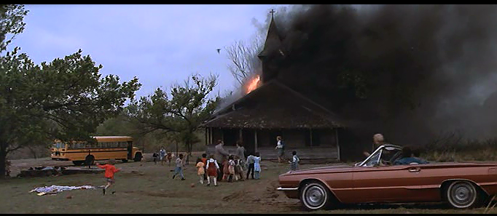
(This was a photo of the church on fire)
“They are hero from the paradise, one of them use his life to save my students life. I was very thankful for them.” Jerry said, one of the teachers of students, he didn’t believe that they are greasers, “they also said they are greaser, I don’t believe at first. In my mind, greasers were tougher colder and meaner, they never help people just want to fight. However, I am off base. They have warm heart and can use their life to save other people. They are more goodness than anyone else.”
One of the Greasers called Ponyboy Curtis described Johnny Cade who taught him a lots that how to be a good person: “They were all my brothers, the dead one called Johnny Cade who was 16 years old and the most goodness guy in my brothers. He taught me a lot when he was alive. He said he doesn’t care who was winner of the rumble between greasers and Socs. Whatever which side wins, they don’t have any benefit, just got hurt and vanity. Don’t have any significance. Before he died, he told me to ‘stay gold’.” “Stay gold” was from <Gone with the Wind > .He read it when he was laid on the sickbed, wait the death came to meet him. Ponyboy said: “Johnny said ‘Stay gold’ was very important, I should know and I need to take Dally to see the sunset, he need to know there were a plenty of nice things on the Earth.”
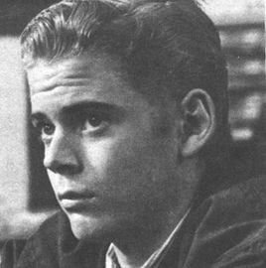 (This was a photo of Ponyboy Curtis.)
Dallas “Dally” Winston was the second oldest one in Ponyboy’s brother. Some persons thought he was tougher colder and meaner. In fact, he wasn’t like they said. “Dally was very love his brothers, he always defends his brothers against injustice. However sometimes, he will tease some kids or girls, he was kind just sometimes do things without thinking.” Ponyboy said.
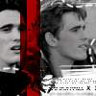 (This was a photo of Dally)
At last Ponyboy discloses some secrets: “In fact, I and Johnny were Delinquents, Johnny killed one Soc called Bob. Johnny killed him just for self-defense and helps me because Socs put my head in the fountain, I was nearly dead. After he killed Bob, we run away to Jay Mountain and stay in the church which was in fire. Then Dally found us and take us to home. On the road, we see the church was in fire. We thought the cigarette we left burn the church. And then we go to save kids in fire, and my good brother, Johnny, return to the paradise.”
Juvenile Delinquents Turn Heroes, “I will remember Johnny forever.” Jerry said.
(This was a photo of Johnny Cade.)

_David made

