To investigate the effect of milk on diffusing heat
- Question
Should Mr.Doyle put milk in his coffee?
- Introduction
- In the investigation I tried to find out the coffee with milk will be cold faster or the coffee without milk will be cold faster. The scientific concepts in this investigation include fair test.
- Prediction
- I think the coffee without milk will be cold faster, because milk is cold and it will make diffuse heat more faster.
- Announcements
- I only can change variable is adding or not adding milk into the coffee.
- I need to control the concentration and volume of coffee need to be same; indoor temperature and the place I put two cups of coffee need to be same.
- Equipment
- The equipment I using: two 250cm³ beakers, 20cm³of milk, thermometer, stopwatch.
- Procedure
- First put 250 cm ³coffee into two beakers, and put 20cm³milk into one of the coffee
- Second put thermometer into two cup of coffee and every 3 minutes record the temperature of coffee.
- Data table
Time(mins) | Temperature ℃
 | Without milk | With milk
0 mins | 75 | 66
3 mins | 60 | 67.5
6 mins | 55 | 61
9 mins | 52 | 56
12 mins | 49 | 53
15 mins | 47 | 50.5

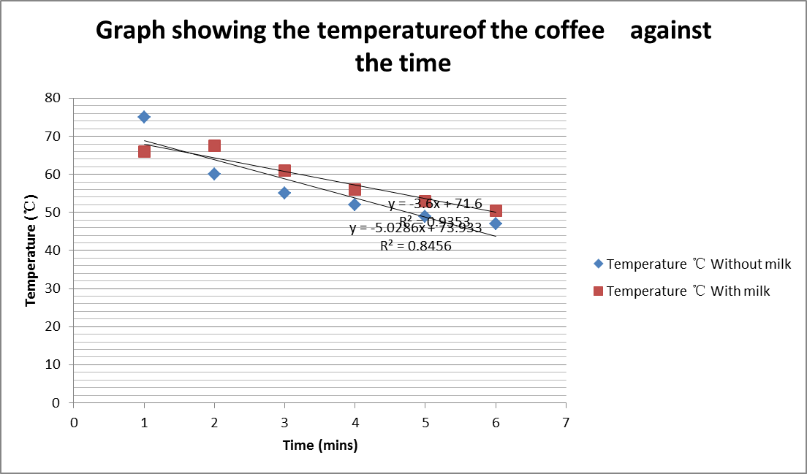
- Conclusion:
we can see from the graph that after 15 minutes, the temperature of black coffee drop from 75 ℃ to 47 ℃ and the coffee with milk drop from 66 ℃ to 50.5 ℃. So coffee with milk will keep warm longer than black coffee. My hypothesis was not validated. We discovered.

- Risk:
Be careful with glassware, hot water.

- Discussion:
From this experiment, I saw that the original temperature of coffee with milk is lower than black coffee because milk is cold. However at last, the coffee with milk is warmer than the black coffee, and less heat was diffusing than the black coffee in each 3 minutes. It seems that there is a relationship between cooler coffee and the rate of diffusing heat. My hypotheses failed because my thermometer which to measure the temperature of coffee with milk is broken. If I will do this again, I will use electronic thermometer to measure the temperature, I think it is more accurate.

